**Submitted by – Sanket Bollamwar**

**Lambda Expressions Assignments**

**1. Write an application to perform basic arithmetic operations like add, subtract, multiply & divide. You need to define a functional interface first.**

**Description:-**

Define Functional Interface and write a program to perform arithmetic operations like add, subtract, multiply and divide using functional interface.

**Examples:**

**Input:-**13       5

**Output:-**

18.0      //Addition of 13 and 5

                                       8.0        //Subtraction of 13 and 5

                                       65.0      // Multiplication of 13 and 5

                                       2.6        //Division of 13 and 5

**FunctionalInterface:-**

A functional interface is an interface that contains only one abstract method. They can have only one functionality to exhibit. From Java 8 onwards, lambda expressions can be used to represent the instance of a functional interface. A functional interface can have any number of default methods. Runnable, ActionListener, Comparable are some of the examples of functional interfaces.

**Specifications:**

public class Assignment4Q1 {  
    public double addition(int num1,int num2){}  
    public double subtraction(int num1,int num2){}  
    public double multiplication(int num1,int num2){}  
    public double division(int num1,int num2){}  
    public static void main(String[] args) {}  
}

**Code:**

package Lambda_Expressions_Assignments;

import java.util.Scanner;

public class Assignment6Q1 {

    interface addition{

        double add(int num1,int num2);

    }

    interface subtraction{

        double sub(int num1,int num2);

    }

    interface multiplication{

        double mul(int num1,int num2);

    }

    interface division{

        double div(int num1,int num2);

    }

    public static addition getAddition(){

        return (num1,num2)->{return num1+num2;};

    }

    public  static  subtraction getSubtraction(){

        return (num1,num2)->{return num1-num2;};

    }

    public static multiplication getMultiplication(){

        return (num1,num2)->{return num1*num2;};

    }

    public static division getDivision(){

        try{

            return (num1,num2)->{return num1/num2;};

        }catch (ArithmeticException e){

            System.out.println(e);

        }

        return null;

    }

    public static void main(String[] args) {

        Scanner sc = new Scanner(System.in);

        System.out.println("Enter the num1: ");

        int a = sc.nextInt();

        System.out.println("Enter the num2: ");

        int b = sc.nextInt();

        System.out.println("Addition = "+getAddition().add(a,b));

        System.out.println("Subtraction = "+getSubtraction().sub(a,b));

        System.out.println("Multiplication = "+getMultiplication().mul(a,b));

        System.out.println("Division = "+getDivision().div(a,b));

    }

}

**Output:**

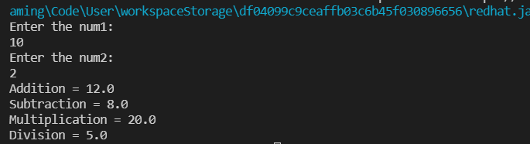

**Q2. Write an application using lambda expressions to print Orders having 2 criteria implemented: 1) order price more than 10000 2) order status is ACCEPTED or COMPLETED.**

**Description:**

Write a program in such a way that it has a method which returns the list of orders satisfying the 2 conditions mentioned in the question.

**Specifications:**

import java.util.ArrayList;  
  
public class Assignment4Q2 {  
  
    private int totalPrice;  
    private String status;  
  
    public static ArrayList<Assignment4Q2> listOfOrders(ArrayList<Assignment4Q2> orders) {}  
    public static void main(String[] args) {}  
}

**Code:**

package Lambda_Expressions_Assignments;

import java.util.ArrayList;

import java.util.Scanner;

public class Assignment6Q2 {

    interface listOfOrders{

        public ArrayList<String> Result(int totalPrice, String status);

    }

    public static listOfOrders orders(){

        return (totalPrice,status)->{

            ArrayList<String> result= new ArrayList<>();

            if(totalPrice>=10000){

                result.add("order price more than 10000");

            }

            else{

                result.add("order price less than 10000");

            }

            result.add(status);

            return result;

        };

    }

    public static void main(String[] args) {

        Scanner sc = new Scanner(System.in);

        System.out.println("Enter the order price: ");

        int price = sc.nextInt();

        System.out.println("Enter the order status: ");

        String status = sc.next();

        ArrayList<String> result = new ArrayList<>();

        result = orders().Result(price,status);

        System.out.println("ORDER STATUS: ");

        for (String i: result){

            System.out.println(i);

        }

    }

}

**Output:**

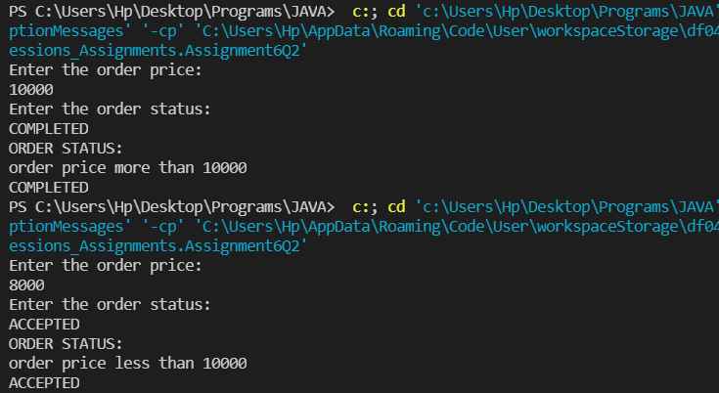

**Q3. Use the functional interfaces Supplier, Consumer, Predicate & Function to invoke built-in methods from Java API.**

**Description:**

Write a program using the Java API’s mentioned in the question.

**Specifications:**

public class Assignment4Q3 {  
    static void modifyValue(){  }  
    static class Product { }  
    static void display() { }  
    public static void main(String[] args) {  
}

**Code:**

**Output:**

**Q4. Remove the words that have odd lengths from the list. HINT: Use one of the new methods from JDK 8. Use removeIf() method from Collection interface.**

**Description: -**

Write a program using java 8 features which can remove the odd length words from the list.

**Specifications:**

public class Assignment4Q4 {  
    public ArrayList<String> removeOddLength(ArrayList<String> employeeList){}  
    public static void main(String[] args) { }  
}

**Code:**

package Lambda_Expressions_Assignments;

import java.util.ArrayList;

import java.util.List;

import java.util.Scanner;

public class Assignment6Q4 {

    interface RemoveOddLenght{

        public ArrayList<String> removeOddLenght(ArrayList<String> Employee);

    }

    public static RemoveOddLenght removeOddLenght(){

        return (Employee)->{

            for(String i: Employee){

                if(i.length()%2!=0){

                    Employee.remove(i);

                }

            }

            return Employee;

        };

    }

    public static void main(String[] args) {

        Scanner sc = new Scanner(System.in);

        ArrayList<String> list = new ArrayList<>();

        System.out.println("Enter the numbers of strings to be inserted: ");

        int n = sc.nextInt();

        for(int i=0;i<n;i++){

            System.out.print("Enter the string: ");

            String str = sc.next();

            list.add(str);

        }

        System.out.println("List before removing odd length words: ");

        for(String i: list){

            System.out.print(i+" ");

        }

        System.out.println();

        list = removeOddLenght().removeOddLenght(list);

        System.out.println("List after removing odd length words: ");

        for(String i: list){

            System.out.print(i+" ");

        }

        System.out.println();

    }

}

**Output:**

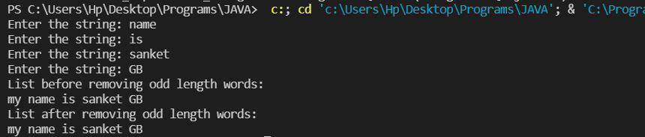

**Q5. Create a string that consists of the first letter of each word in the list of Strings provided. HINT: Use Consumer interface & a String Builder to construct the result.**

**Description:**

Write a java program using StringBuilder and Consumer interface which will return a string. The returned string should consistes of the first let of each word in the list of words.

**Specifications:**

public class Assignment4Q5 {  
    List<String> list = Arrays.*asList*("alpha", "bravo", "charlie", "delta", "echo", "foxtrot");  
  
    public static void main(String[] args) { }  
  
    public static String processWords(List<String> list) {}  
}

**Code:**

package Lambda_Expressions_Assignments;

import java.util.Arrays;

import java.util.List;

public class Assignment6Q5 {

    static List<String> list = Arrays.asList("alpha", "beeta", "ceeta", "delta", "eeeta", "feeta");

    interface ProcessWords{

        public String processWords(List<String> list);

    }

    public static ProcessWords processWords(){

        return (list)->{

            String result = "";

            for (String i: list){

                result += i.charAt(0);

            }

            return result;

        };

    }

    public static void main(String[] args) {

        String ans;

        ans = processWords().processWords(list);

        System.out.println("String formed by using first letter of each word in the list of words: "+ans);

    }

}

**Output:**

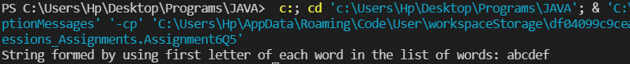

**6. Replace every word in the list with its upper case equivalent. Use replaceAll() method & Unary Operator interface.**

Using replaceAll() method and Unary Operator interface write a java program which replaces evry word in the list with its upper case equivalent.

**Specifications:**

public class Assignment4Q6 {  
    public static void main(String[] args) {}  
    public List<String> convertToUpperCase(List<String> list) {}    
}

**Code:**

package Lambda_Expressions_Assignments;

import java.util.Arrays;

import java.util.List;

import java.util.Locale;

public class Assignment6Q6 {

    interface  ConvertToUpperCase{

        public List<String> convertToUpperCase(List<String> list);

    }

    public static ConvertToUpperCase convertToUpperCase(){

        return (list)->{

            list.replaceAll(i-> String.valueOf(i.charAt(0)).toUpperCase()+i.substring(1));

            return list;

        };

    }

    public static void main(String[] args) {

        List<String> list = Arrays.asList("alpha", "beeta", "ceeta", "delta", "eeeta", "feeta");

        System.out.println("List before converting first letter to uppercase: ");

        for (String i: list){

            System.out.println(i+" ");

        }

        System.out.println();

        list = convertToUpperCase().convertToUpperCase(list);

        System.out.println("List after converting first letter to uppercase: ");

        for (String i: list){

            System.out.println(i+" ");

        }

        System.out.println();

    }

}

**Output:**

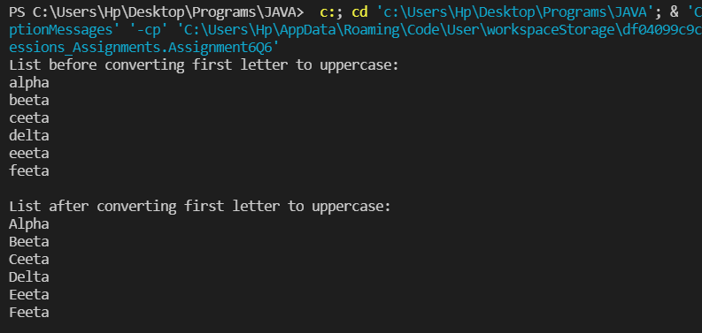

**7. Convert every key-value pair of the map into a string and append them all into a single string, in iteration order. HINT: Use Map.entrySet() method & a StringBuilder to construct the result String.**

**Description:-**

Write a java program using Map.entrySet() method & a StringBuilder which will return a string by appending all the key value pairs of a map into a single string ,in insertion order.

**Specifications:**

public class Assignment4Q7 {  
    public static void main(String[] args) {}  
    public String convertKeyValueToString(HashMap<String, Integer> map) {}  
}

**Code:**

package Lambda_Expressions_Assignments;

import java.util.HashMap;

import java.util.Map;

public class Assignment6Q7 {

    interface ConvertKeyValueToString{

        public String convertKeyValueToString(HashMap<String, Integer> map);

    }

    public static  ConvertKeyValueToString convertKeyValueToString(){

        return (map)->{

            String result="";

            for(Map.Entry<String,Integer> mp: map.entrySet()){

                String key = mp.getKey();

                int value = mp.getValue();

                result += key + Integer.toString(value);

            }

            return result;

        };

    }

    public static void main(String[] args) {

        HashMap<String, Integer> hashMap = new HashMap<>();

        hashMap.put("Sanket",1);

        hashMap.put("Ansh",2);

        hashMap.put("Jayant",3);

        hashMap.put("Prajwali",4);

        hashMap.put("Mrunal",5);

        System.out.println("String after append key-value all pairs into a single string:\n");

        System.out.println(convertKeyValueToString().convertKeyValueToString(hashMap));

    }

}

**Output:**

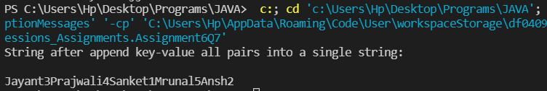

**Q8. Create a new thread that prints the numbers from the list. Use class Thread & interface Consumer.**

**Description:-**

Write a java program which will print the list of number using Thread and interface Consumer.

**Specifications:**

public class Assignment4Q8 {}

**Code:**

package Lambda_Expressions_Assignments;

import java.util.Arrays;

import java.util.List;

class Thread extends java.lang.Thread{

    public void Display_Numbers(List<Integer> list){

        for (int i:list){

            System.out.print(i+" ");

        }

    }

}

public class Assignment6Q8 {

    public static void main(String[] args) {

        Thread thread = new Thread();

        thread.start();

        List<Integer> list = Arrays.asList(1,2,3,4,5,6,7,8,9,10);

        System.out.println("Printing numbers from the list: ");

        thread.Display_Numbers(list);

        thread.stop();

    }

}

**Output:**

